Pocket-sized file backup

[Watch Video](https://www.kingston.com/en/video/play?videoId=XTiBiaC6kU0cifqXZzfOBLmW4mCR-ZHDPIwkjxSuxY_HoL9ofQoAKxEnyeYDDKYvnPiIaNvVV7uY3kuDqLd3VA2&start=0&autoPlay=False&chromeless=False&captionOption=No)

XS1000

* [Intro](https://www.kingston.com/en/ssd/xs1000-external#product-features)
* [Key Features](https://www.kingston.com/en/ssd/xs1000-external#key-feature)
* [Specifications](https://www.kingston.com/en/ssd/xs1000-external#specifications)
* [Reviews](https://www.kingston.com/en/ssd/xs1000-external#review)
* [Resources](https://www.kingston.com/en/ssd/xs1000-external#links)
* [Datasheet](https://www.kingston.com/datasheets/xs1000_us.pdf)

[**Buy**](https://www.kingston.com/en/ssd/xs1000-external#atc)

XS1000 External Solid State Drive (SSD)USB 3.2 Gen 2 External Drive

Kingston’s XS1000 external SSD is an incredibly convenient file backup solution. Its sleek, compact form factor is designed to fit seamlessly into your lifestyle, allowing you to carry it anywhere with ease. Don't let its size fool you – this tiny powerhouse boasts speeds up to 1,050MB/s1 and high capacities up to 2TB2, providing ample speed and space to store your valuable data. Compatible with both USB Type-C®3 and USB Type-A devices with the included cable and adapter4 to provide unrivaled convenience and impressive storage capabilities, the XS1000 is your reliable companion for hassle-free file backup, ensuring your important documents, cherished memories, and media files are always readily accessible. Say goodbye to bulk and hello to streamlined storage efficiency with the XS1000 External SSD. Available in black or red with optional rubber sleeves sold separately.5

* Compact, pocket-sized form factor
* Speeds up to 1,050MB/s1 with USB 3.2 Gen 2
* Increased storage up to 2TB2

Key Features

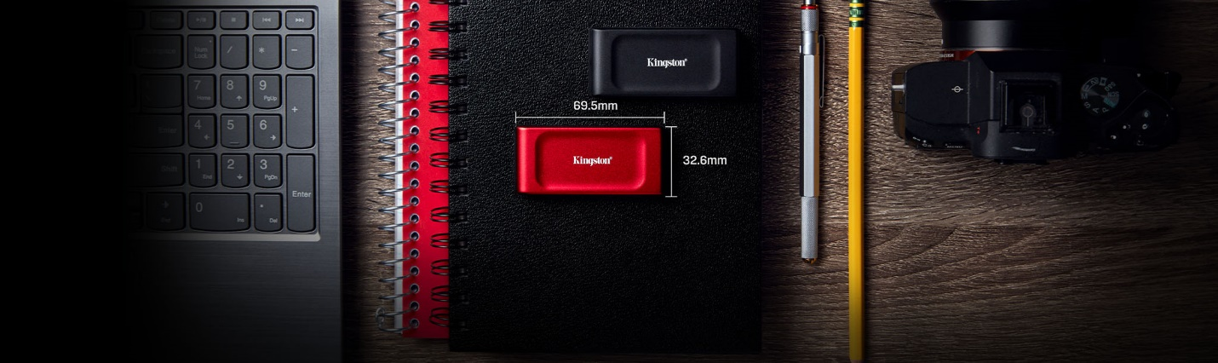

Ultimate portability

Compact and weighing just under 29g, this sleek SSD is available in black or red and fits comfortably in your palm, allowing you to take your files on the go effortlessly.



Reliable file backup

Take it all with you. Transfer and store your documents, large photos and videos without interruption.



Increased storage

Expand your digital library with high capacities up to 2TB2. Compatible with the latest iOS devices, Android platforms and gaming consoles6.



USB 3.2 Gen 2 support

Achieve read/write speeds up to 1,050MB/s1 with backwards compatibility to USB 3.2 Gen 1 ensuring seamless connectivity with legacy devices.



Award-winning design

Kingston’s XS1000 was awarded with the Red Dot Design Award in 2024.



Awards and Reviews

Once again Kingston has another winner in a portable solid state drive. In terms of speed this is a USB 3.2 gen 2 drive so the rated speed are 1050 MB/s read and 1000 MB/s write and the drive performed right up to those specifications. I also did like that the included cable with the drive is USB-C to USB-A, which allows this drive to work for more people, especially desktop users.

[Read Full Review](https://thinkcomputers.org/kingston-xs1000-portable-solid-state-drive-review/)